Circuit Analysis (Lab11)

Experiment 10: Verification of Norton’s Theorems

Name: Muhammad Abdullah Registration No: 2025- CE -54
Date:---- Grade and Signature: ……………………
CLO2 CLO3 | Use with identification the circuit components, breadboards, multimeter, power supplies, signal generators, and oscilloscopes. Make measurements in their own constructed electric circuits.
Psychomotor/Affective | Level1  (1) | Level2 (2-3) | Level3 (4-5) | Level4 (6-7)
Report Marks (3)
 | Total marks (10)

Objective
The objective of this lab is verify Nortan’s theorem and to find the full load current.

Apparatus Required
Sr. no | Apparatus | Range | Quantity
1 | Regulated Power Supply | Standard | 1
2 | Signal Generator | Standard | 1
3 | Oscilloscope | Standard | 1
4 | Digital Multimeter | Standard | 1
5 | Breadboard & Wires | Standard | As Required
6 | Resistors | 1k, 330 ohms | 1,3
7 | Potentiometer | Standard | 1

Description
Statement:

Any linear circuit can be simplified to an equivalent circuit consisting of a single current source and parallel resistance that is connected to a load.
Precautions:
- Voltage control knob of RPS should be kept at minimum position.
- Current control knob of RPS should be kept at maximum position

Procedure for Norton’s Theorem:
- Connections are given as per circuit diagram.
- Set a particular value in RPS and note down the ammeter readings in the original circuit.

To Find I_{N}:
- Remove the load resistance and short circuit the terminals.
- For the same RPS voltage note down the ammeter readings.

To Find R_{N}:
- Remove RPS and short circuit the terminal and remove the load and note down the resistance across the two terminals.

Equivalent Circuit:
- Set IN and RN and note down the ammeter readings.
- Verify Norton’s theorem.

To find load current in circuit 1:
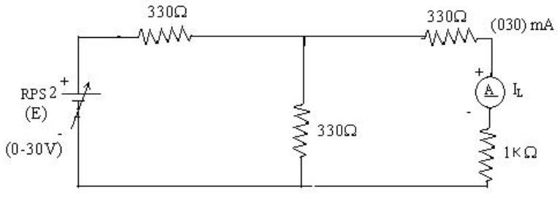

To find I_{N}
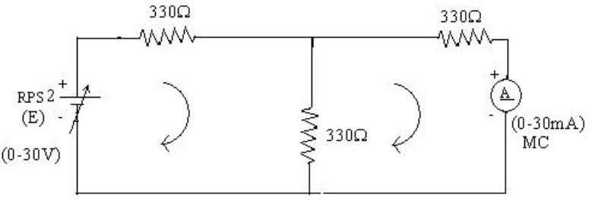

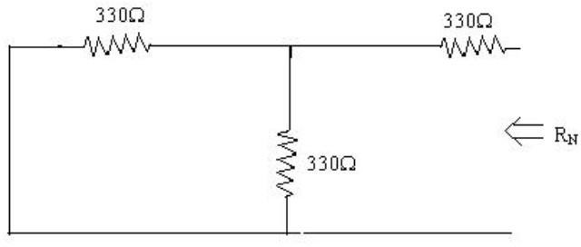
To find R_{N}

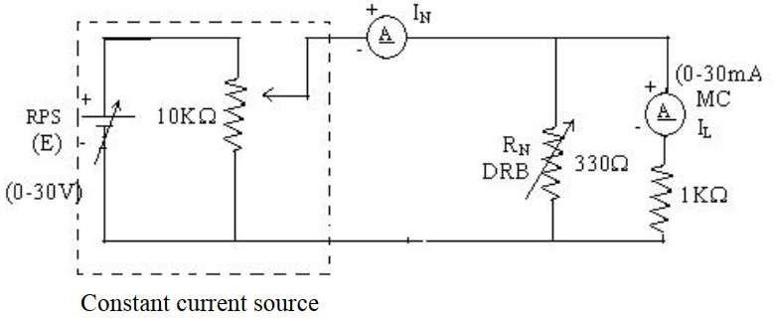
Norton’s equivalent circuit

Norton’s Practical Values
 | E (volts) | IN (mA) | Rn  (ohms) | IL (mA)
 |  |  |  | Circuit - I | Equivalent Circuit
Practical Values | 10 10.10 |  | 495 | 3.34 | 3.34

Post Lab Questions

1. What is Norton’s Theorem?
Norton’s Theorem states that any linear electrical network can be replaced by an equivalent circuit.
The equivalent circuit consists of a current source called Norton current.
It also contains a parallel resistance called Norton resistance.
This theorem simplifies the analysis of complex circuits.
It is mainly used to determine load current and voltage easily.

2. What are the applications of Norton’s Theorem?
Norton’s Theorem is used to simplify complicated electrical networks.
It helps in calculating current through different load resistors.
The theorem is widely used in circuit analysis and design.
It is useful in electronic and power system applications.
It also helps in studying the effect of changing load conditions.

3. What are the theoretical and practical limitations of Norton’s Theorem?
Norton’s Theorem is applicable only to linear and bilateral circuits.
It cannot be directly applied to non-linear devices like diodes and transistors.
The theorem becomes difficult to use in highly complex circuits.
It is not suitable for circuits with only dependent sources without special treatment.
Practical component tolerances and measurement errors can reduce accuracy.

